Whole foods cheat sheet
Brought to you by pounds transformation

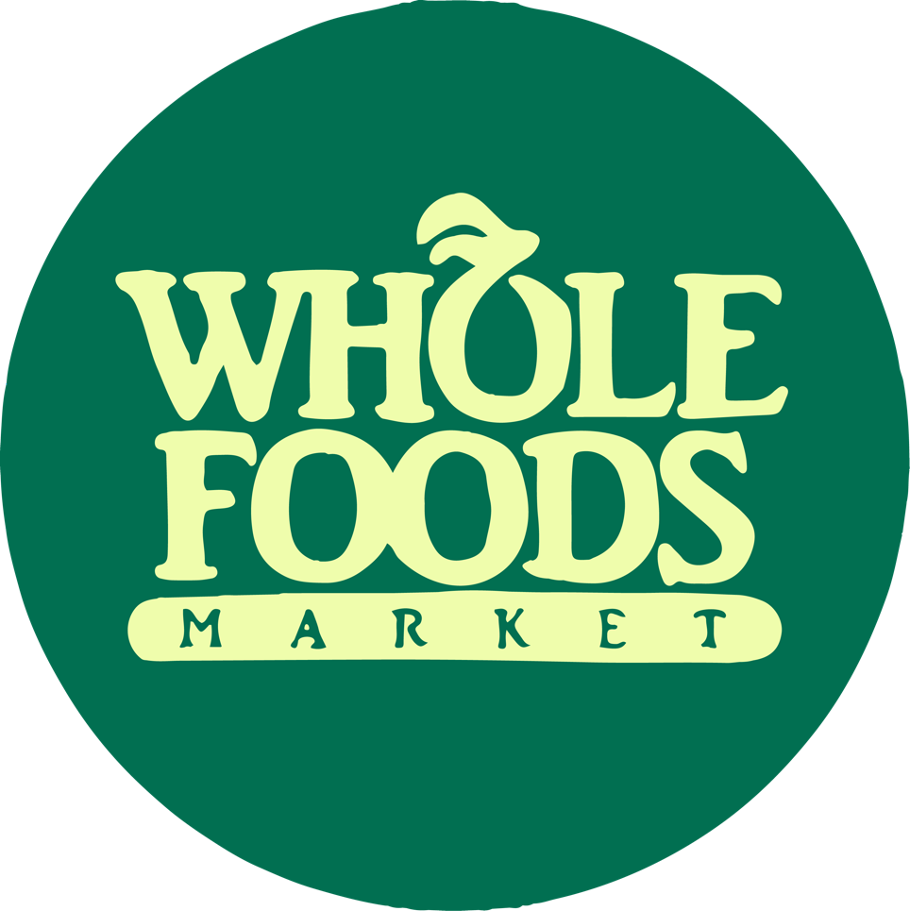

*Easy grab n’ go & precooked options!
Meats:
- Bel & Evan’s Chicken Burger (3 g net carbs, 21 g protein)
- Whole Foods Organic Spicy Italian Chicken Sausage (1 g net carb, 14 g protein)
- Applegate Chicken & Maple Breakfast Sausage (1 g net carb, 5 g protein)
- The Organic Meat Company 100% Grass Fed Beef Burgers (0 g net carb, 15 g protein)
- Applegate Pork & Beef Uncured Pepperoni (0 g net carb, 8 g protein)
- 365 Seasoned Roast Beef (1 g net carb, 14 g protein)
- Gusto Genoa Salami Packs (0 g net carb, 12 g protein)
- 365 Black Forest Uncured Ham (1 g net carb, 11 g protein)
- Applewood Smoked Uncured Bacon (0 g net carb, 5 g protein)
- Applegate Turkey Breast Slices (1 g net carb, 11 g protein)
- Applegate Organic Uncured Beef Hot Dog (0 g net carb, 9 g protein)

Vegetarian:
- 365 Plant-Based Chicken Style Bites (5 g net carbs, 16 g protein)
- Tofurky Plant Based Deli Slices (4 g net carbs, 14 g protein)
- Gardein Beefless Ground (2 g net carbs, 18 g protein)
- Smart Dogs Vegan Hot Dogs (2 g net carbs, 7 g protein)
- 365 Plant Based Breakfast Patties (3 g net carb, 7 g protein)
- Good Catch “Fish” Burgers (7 g net carbs, 21 g protein)
- The Bridge Tofu Salad (1 g net carb, 6 g protein)
- Natural Power-Fu Vegetarian Chicken Salad (0 g net carb, 9 g protein)

Prepared Foods:
- Whole Foods Classic Chicken Salad (3 g net carbs, 21 g protein)
- “Mom’s” Chicken Soup (4 g net carbs, 11 g protein)

Breads/Cereals/Pasta:
- Outer Aisle Cauliflower Sandwich Thins (2 g net carbs, 9 g protein)
- Siete Almond Flour Wraps (GF) (4 g net carbs, 3 g protein)
- Carbonaut Bread (GF) (1 g net carb, 0 g protein)
- The Better Bagel (5 g net carbs, 25 g protein)
- Crepini Cauliflower Wraps (0 g net carb, 1 g protein)
- Miracle Rice (0 g net carb, 0 g protein)
- Miracle Noodles (1 g net carb, 0 g protein)
- Palmini Hearts of Palm Pasta / Rice (2 g net carbs, 1 g protein)
- Palmini Lasagna Sheets (2 g net carbs, 1 g protein)
- Catalina Crunch Cereal (5 g net carbs, 11 g protein)
- Paleonola Grain Free Original Granola (5 g net carbs, 4 g protein)

Dairy:
- Blue Diamond Unsweetened Almond Milk (1 g net carb, 1 g protein)
- Ripple Unsweetened Pea Milk (0 g net carb, 8 g protein)
- Good Karma Flax Milk (2 g net carbs, 8 g protein)
- Fage Plain Greek Yogurt (5 g net carbs, 16 g protein)
- Green Valley Greek Yogurt (Lactose Free!) (8 g net carbs, 8 g protein)
- Good Culture Cottage Cheese (3 g net carbs, 14 g protein)
- 365 String Cheese (0 g net carb, 7 g protein)
- Califia Farms Unsweetened Creamer (0 g net carbs, 0 g protein)
- Nut Pods Unsweetened Creamer (0 g net carbs, 0 g protein)
Snacks:
- Wilde Protein Chips (7 g net carbs, 10 g protein)
- Flackers Crackers (1 g net carb, 5 g protein)
- Perfectly Crisp Crackers (1 g net carb, 9 g protein)
- NuGo Slim Bar (Vegan) (12 g net carbs, 17 g protein)
- OWYN Protein Shake (Dairy Free) (3 g net carbs, 20 g protein)
- Archer 0 Sugar Beef Jerky (2 g net carbs, 12 g protein)
- Epic Oven-Baked Pork Rinds (0 g net carb, 11 g protein)
- Moon Cheese (1 g net carb, 11 g protein)
- Gimme Seaweed Snacks (0 g net carb, 0 g protein)
- Original Salami Minis (0 g net carb,8 g protein)

Miscellaneous:
- Yo Mama’s Basil Tomato Sauce (4 g net carbs, 1 g protein)
- Cucina Antica Truffle Alfredo Sauce (4 g net carbs, 2 g protein)
- 365 Avocado Greek Yogurt Dressing (2 g net carbs, 1 g protein)
- 365 Italian Dressing (0 g net carb, 0 g protein)
- Acid League Miso Cesar Dressing (2 g net carbs, 1 g protein)
- Yosi Tzatziki Sauce (2 g net carbs, 1 g protein)
- Kitehill Dairy-Free Tzatziki (2 g net carbs, 1 g protein)
- Kitehill Dairy-Free French Onion Dip (2 g net carbs, 1 g protein)
- PB Fit Protein Peanut Butter (5 g net carbs, 10 g protein)
- 365 Mini Guacamole Cups (2 g net carbs, 1 g protein)
- Kos Protein Powder (vegan!) (6 g net carbs, 20 g protein)
- Vital Proteins Collagen Peptides (unflavored!) (0 g net carb, 20 g protein)

